Laboratorio 16.5.1

Marco Ayala

Séptimo A

Resultado del Laboratorio

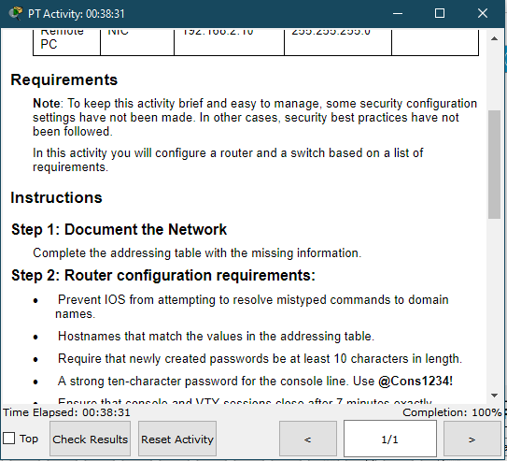

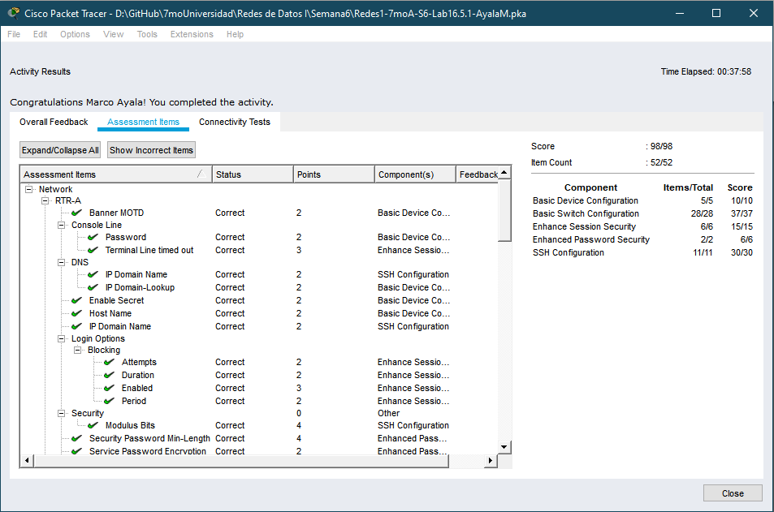

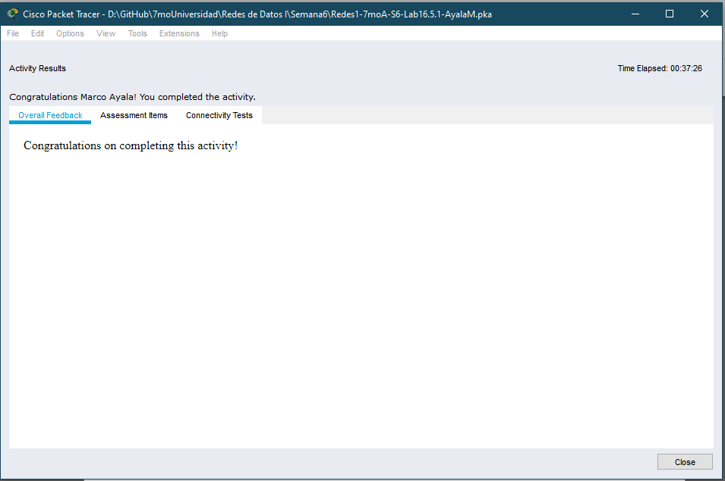

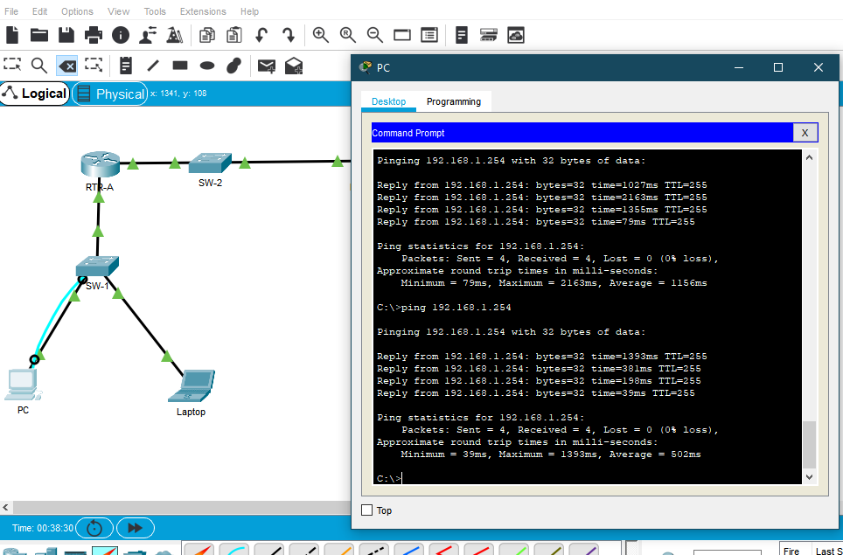

**Anexos**

Tablas de direcciones

|  |  |  |  |  |
| --- | --- | --- | --- | --- |
| **Device** | **Interface** | **Address** | **Mask** | **Gateway** |
| RTR-A | G0/0/0 | 192.168.1.1 | 255.255.255.0 | N/A |
| *RTR-A* | G0/0/1 | 192.168.2.1 | 255.255.255.0 | N/A |
| SW-1 | SVI | 192.168.1.254 | 255.255.255.0 | 192.168.1.1 |
| PC | NIC | 192.168.1.2 | 255.255.255.0 | 192.168.1.1 |
| Laptop | NIC | 192.168.1.10 | 255.255.255.0 | 192.168.1.1 |
| Remote PC | NIC | 192.168.2.10 | 255.255.255.0 | 192.168.2.1 |